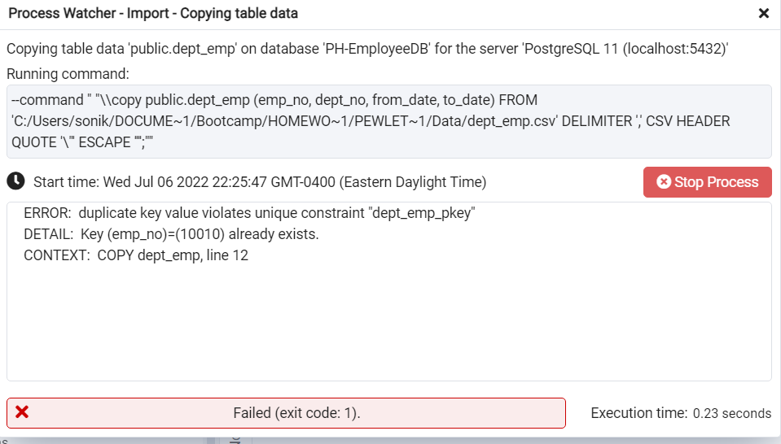

Deleted these duplicate values from dept_emp

|  |  |  |  |
| --- | --- | --- | --- |
| 10010 | d004 | 11/24/1996 | 6/26/2000 |
| 10010 | d006 | 6/26/2000 | 1/1/9999 |

